Authentication Service Returning JWT – Spring Boot
Spring REST using Spring Boot 3 – Week 4 Exercise

Objective
The goal of this exercise was to build an authentication service in Spring Boot that generates and returns a JWT (JSON Web Token) once a user's credentials are validated. The idea is simple: a client sends a request with a username and password using HTTP Basic authentication, and if the credentials are correct, the service responds with a signed token that can later be used to access protected resources.

Approach
I broke this down into three parts, as suggested in the exercise:
- Set up an authentication controller and wired it into a SecurityConfig class so that the /authenticate endpoint is protected using HTTP Basic authentication.
- Let Spring Security handle reading the Authorization header and decoding the username and password automatically, instead of writing custom decoding logic.
- Once the user is authenticated, generate a JWT for that user using the JJWT library, sign it, and return it in a JSON response.

Implementation Details
The project was created as a Maven-based Spring Boot application with the following dependencies: spring-boot-starter-web, spring-boot-starter-security, and the JJWT library (jjwt-api, jjwt-impl, jjwt-jackson) for creating and signing tokens.
Key classes I created:
- SecurityConfig — configures a stateless security filter chain, disables CSRF (since this is a stateless REST API), and enables HTTP Basic auth on the /authenticate endpoint.
- UserConfig — defines an in-memory user (username: user, password: pwd) for testing purposes, using Spring Security's UserDetailsService.
- JwtUtil — a utility class that builds and signs the JWT using HS256, setting the subject as the username, the issued-at time, and a 20-minute expiry.
- AuthenticationController — exposes a GET /authenticate endpoint. It picks up the already-authenticated user from the Authentication object (populated automatically by Spring Security after decoding the Basic auth header) and calls JwtUtil to generate the token, returning it as {"token": "..."}.

Running and Testing
I ran the application directly from IntelliJ by running the main method in JwtAuthServiceApplication. The console log confirmed that Tomcat started on port 8090 and the application came up successfully:
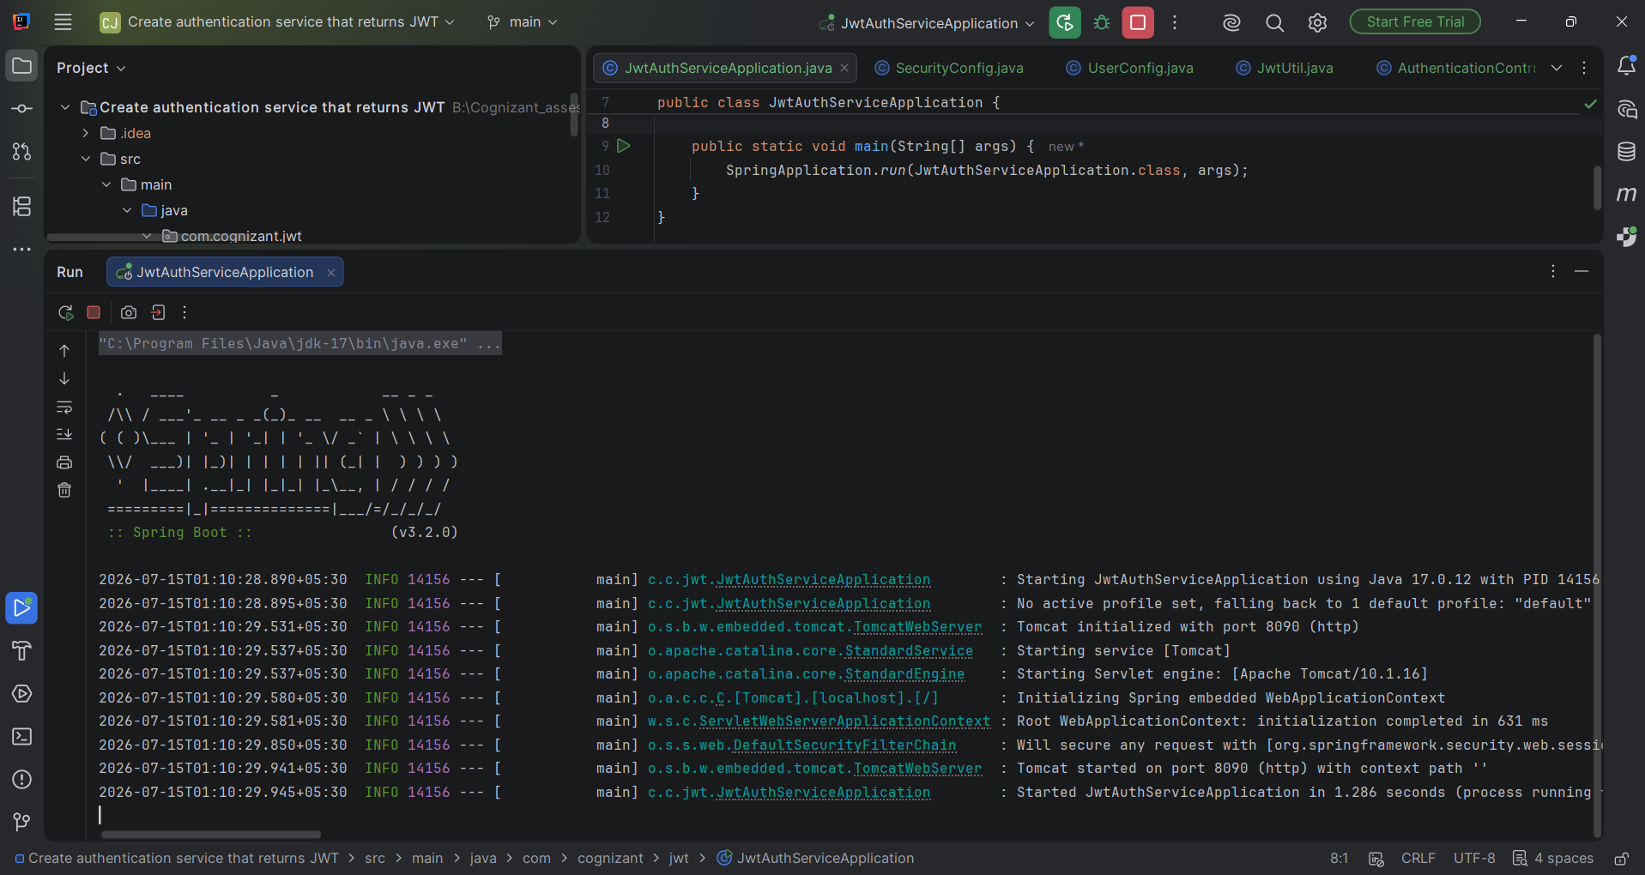
Application started successfully on port 8090
To verify the endpoint, I opened a terminal and ran the following curl command, passing the username and password using the -u option, exactly as required by the exercise:
curl.exe -s -u user:pwd http://localhost:8090/authenticate
The service responded with a valid JWT wrapped in a JSON object, confirming that the authentication and token generation flow worked as expected:
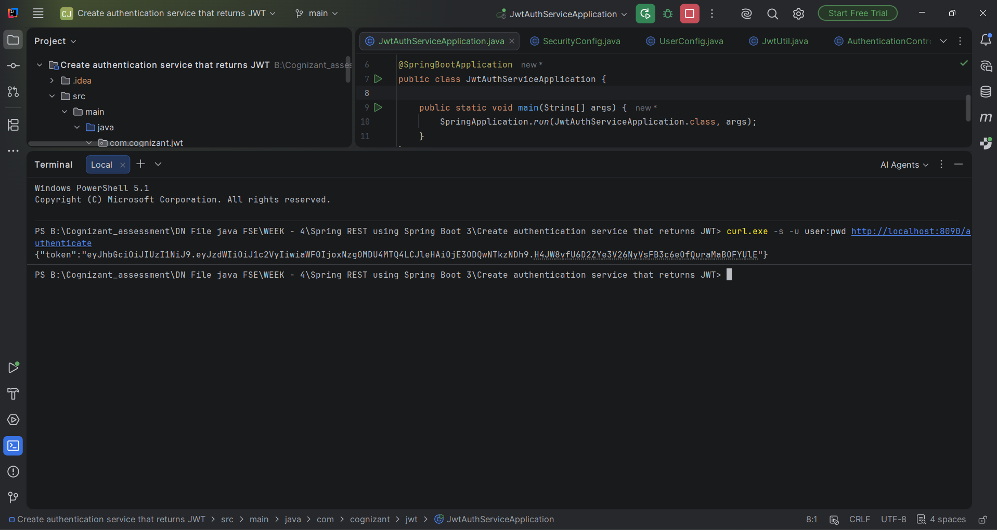
curl request returning the generated JWT

Outcome
The authentication service now successfully authenticates a user via HTTP Basic auth and returns a signed JWT in response, matching the exact request/response format specified in the exercise. All three sub-tasks — setting up the controller and security config, decoding credentials from the Authorization header, and generating the token — were completed and verified end to end.

